MANITOWOC COUNTY FISH & GAME
MEMORIAL PARK BRICK PROGRAM

Manitowoc County Fish & Game has established a Memorial Park to recognize deceased members of our sportsmen’s clubs who during their lifetime supported the mission and legacy of conservation in our county.
You can pave the way to a lasting legacy and remember them with an engraved brick.
I would like to purchase a brick at the Fish & Game Memorial Park.
The cost of a 4" by 8" brick is $125.00
Please engrave the brick as follows:
*All text on each line will be centered*
*Maximum of 12 characters per line*

RETURN THIS FORM AND YOUR CHECK PAYABLE TO:
MANITOWOC COUNTY FISH & GAME
PO. BOX 003
MANITOWOC, WI 54221
BY APRIL 1st, 2026

Location of the park is 14107 Newton Rd, Valders, WI 54245
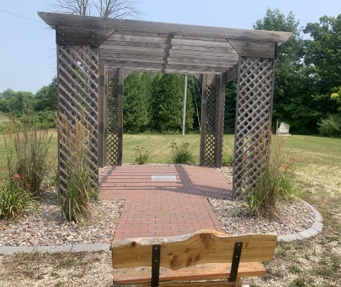
Half mile east of the intersection of Pigeon Lake Rd. and Newton Rd.
